Soldier Combat

Introduction

This document covers the items necessary for successful soldier combat in FEAR. Assassins, Heavy Armor, and Powered Armor enemies are covered elsewhere. First a brief description of the AI_SoldierCombat01 tutorial level is presented. Next the various nodes used to have enemies behave intelligently is discussed. Finally, a discussion of Nav Meshes and some of the Nav Mesh links that are used to get enemies to jump over walls and move down stairs is given.

AI_SoldierCombat01 Tutorial level

This level is best played in God mode. When you step on the small platform in the corner 4 enemies are spawned behind the wall on the balcony. They will jump over the walls and use the cover nodes to attack. When an enemy is killed another will spawn in his place. This provides a continuous wave of enemies and provides plenty of opportunities to see them use the links and nodes.

Figure 1 shows a top view of the level as seen in the level editor. Blue squares are combat nodes, while the orange squares are ambush nodes. The setup of these nodes is described in greater detail below.

A are pillars the enemies can hide behind.
B is a wall with a crawl link the enemies can crawl under.
C is a wall the enemies dive over.
D is a bench the enemies jump over.
E is the region the enemies start at.
F is the wall the enemies must jump over to get to the combat area.
G is the trigger that spawn the enemies.
X is the player start location.

Figure 1: Top view of the AI_SoldierCombat01 level as seen in the level editor.

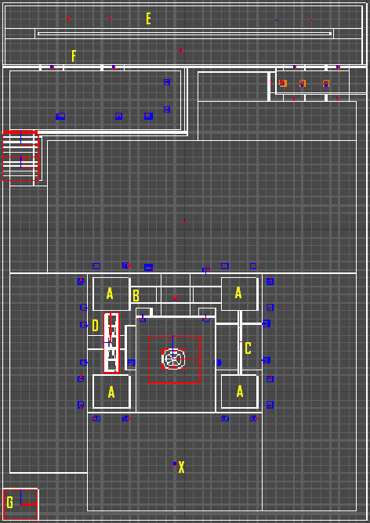

Nodes

Cover Nodes

Where found: AINodes\AINodeCover

The AINodeCover is the most common node used for soldier combat. There are 5 parameters that determine whether an AI will use a node and what animations it will play while at it.

- FOV (field of view): this is the angle around the direction a node is facing. If the player is within the FOV then the node can be valid.
- Radius or Region is the area the AI must be within to consider using the node.
- BoundryRadius or BoundryRegion is the area the player must be within for the node to be usable.
- ThreatRadius or ThreatRegion – if the player is within this area then the AI will retreat.
- SmartObject determines the animations the AI can use while at the node.

Further descriptions of these parameters are given here.

FOV

The field of view is the range of angles (0-360) the player must be within the direction the node is pointing to be valid. The direction a node is pointing is indicated by the blue line coming from the nodes center. This direction can be changed with the Yaw parameter of Rotation. The FOV default value of 20 seems a little low, and setting it to 40-50 seems more reasonable.

Radius and Region

The radius is the maximum distance (in cm) from the node the AI can be for it to consider using the node. For example, if the AI is 1500 cm from a node and its radius is 1000, then the AI will not consider using this node until it gets closer. You can also specify a Region that the node must be within to be used and it will use this instead of distance to determine usability. For example, if you had a room enclosed in a region named Region01 and set the value of Region to “Region01”, then whenever the AI is within Region01 the node will be considered valid for use (providing it fulfills the other requirements).

ThreatRadius and ThreatRegion

When the player comes within the ThreatRadius the node will become invalid, and any enemy standing on it will attempt to retreat. Instead of using a ThreatRadius a ThreatRegion can be specified. The ThreatRegion is a region that once the player enters any enemy using the node will retreat.

BoundryRadius and Boundryregion

The BoundryRadius is the distance from the node (in cm) the player must be from the node for it to be considered valid. Alternatively a BoundryRegion can be used. If the player is within region specified by BoundryRegion the node will be considered.

SmartObject

The smart object determines which animation the AI will play while using the node. CoverDuck, CoverDuckPeek, CoverDuckStand, and CoverStep are the four choices used for the soldiers.

CoverDuck Nodes

The CoverDuck, CoverDuckPeek, and CoverDuckStand smart objects have the player crouch and shoot over a wall. A wall height of 100cm or less works well. It is best to place the node 100cm behind the wall, otherwise the player animations can have the gun clipping through the wall.

CoverStep

This smart object has the soldier step to the side and shoot around a corner. The AI will step to the direction the red arrow faces. The Roll value of Rotation will determine which direction the red arrow faces. Values of 0 and 180 are used for setting the Roll to the proper directions. The Yaw value determines the direction the node faces (blue arrow).

Figure 2 shows some AINodeCover objects as seen in the level editor. Nodes labeled A use the CoverStep smart object, while B uses the CoverDuck smart object. The direction the AI will face when using the node is shown by the blue line, and is set by the Yaw value of Rotation. The direction the AI will step to is given by the red line, which is set by the Roll value. A1 has Yaw and Roll values of 180 and 0, while A2 has Yaw and Roll values of 180 and 180. A3 has Yaw and Roll values of 270 and 0, while A4 has Yaw and Roll values of 270 and 180.

B is a node with a CoverDuck smart object. For this node the facing direction (Yaw) value is most important. The CoverDuck animations do not involve stepping, so the Roll (red line) direction is not relevant.

Figure 2: AINodeCover objects (blue boxes) as seen in the level editor.

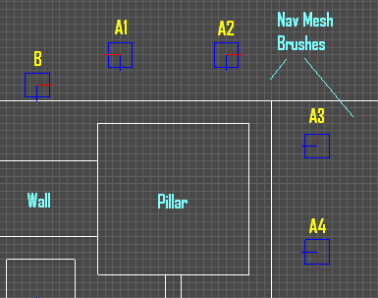

Figure X: A1-A4 are AINodeCover objects with a CoverStep smart object. AI will face in the direction of the blue line and step in the direction of the red line. B is an AINodeCover object with a smart object of CoverDuck. The AI will face in the direction of the blue arrow. For CoverDuck animations the direction of the red arrow is unimportant.

Ambush Nodes

Where found: AINodes\AINodeAmbush

There are two uses for Ambush Nodes.
- Locations you want enemies to go to and fight from, but you don’t want them using the Cover Node animations. Open catwalks are good examples. Enemies will run to the Ambush Nodes and fire from the catwalk, but they will not play an inappropriate animation (like stepping to the side) while doing so.
- Locations behind corners or other cover (ie., good ambush points) that you want the enemies to wait for the player to come into view before firing.

The two values that can be set Ambush Nodes that are different from Cover Nodes are MinExpiration and MaxExpiration. These are the minimum and maximum amounts of time (in seconds) that an AI will wait at these nodes while waiting for a player to appear. The default values are 3 and 20 seconds. What this means is that when an AI arrives at the node it will wait at least 3 seconds for the player to come into view before deciding whether to move on. If after 20 seconds the player has still not appeared then the AI will move to a new location.

Position of Nodes

Some tips for the placement of nodes are:

- CoverStep nodes should be approximately 70 cm behind and 30 cm within the corner the AI is to shoot around. If the node is too close to the wall then the AI will clip into the wall during some animations. There is a fair amount of leeway on these distances, but these are good starting points which can be adjusted as the level is tested.
- CoverDuck nodes are best placed 100 cm behind the wall. Many of the CoverDuck animations will have the AI’s gun clipping into or through the wall if the node is closer.

Node values and enemy aggrssiveness

The BoundryRadius value can be used to effect how close enemies will try to get to the player during combat. The BoundryRadius effects how far from the player the node must be before it is considered valid. If you want enemies to charge the player then using nodes with smaller BoundryRadius values will have them get closer to the player before firing.

Nav Mesh

The Nav Mesh determines what areas the AI can travel to in a level. Nav Mesh construction and links are more completely discussed in another tutorial, and will only briefly be touched upon here. Only the links used in this level will be discussed.

Construction of a Nav Mesh

The Nav Mesh is an AINavMesh object with the brushes that define the area the AI can cover placed underneath it in the Node tree. The Nav Mesh brushes are commonly placed 20 cm above the floor. AI will ignore collision when running on a Nav Mesh, so if the mesh goes through a wall then the AI will run through wall.

Note: Any objects or brushes placed under the Nav Mesh node in the node tree become part of the Nav Mesh. If you accidentally place a prefab under the Nav Mesh node it will not show up in game. If you place a Node under the Nav Mesh node it will not be used in game.

Nav Mesh links used in this level are:

AINavMeshLinkDiveThru

This link has the AI dive and roll over a wall. The dive animation begins where the brush of the link starts. The link works in both directions, and placement of the link object has no effect on the height or length of the dive. The animation is designed for jumps of 100 cm or less. For diving over a wall 20 cm wide (standard FEAR wall width) by 100 cm high placing the link within the wall and not extending out works best. If the link brush extends past the wall then the AI appears to clip through the wall during the dive.

AINavMeshLinkStairs

Stairs in FEAR have a width of 30 cm and a height of 20 cm. The animations AI use when walking on a stairs link are designed for these dimensions.

AINavMeshLinkCrawl

This link has soldiers crawl on the ground under and opening. AI can shoot while crawling. It is probably best to have the opening at least 50 cm high so the AI does not clip into the wall. The start and end of the crawling animation is determined by the length of the link brush.

AINavMeshLinkJumpOver

This link has the AI play a jumping animation. Unlike the Dive Over link, for this link the Link object and brush length determine the height and length of the jump. The height depends on the placement of the link object above the ground – the AI’s feet are level with the object height. The length of the jump is equal to the length of the link brush.

When using this link the AI will stop and assume the “start jump animation” position before jumping, so the transition from a run to the jump is awkward. Due to the poor transition this is an awkward link to use in game, but is included here so you can see it in action.

